AUTOMATED NETWORK REQUEST MANAGEMENT
ServiceNow Custom Application

Final Project Report
Platform: ServiceNow
Project: Automated Network Request Management
Scope: Service Catalog, Approvals and Flow Designer Automation
Document: Implementation, Catalog, Automation and Testing Report
Student Name: Jetti Harika
Date: 09 September 2026

TABLE OF CONTENTS
1. INTRODUCTION 3
1.1 Project Overview 3
1.2 Purpose 3
2. IDEATION PHASE 5
2.1 Problem Statement 5
2.2 Empathy Map Canvas 5
2.3 Brainstorming 6
3. REQUIREMENT ANALYSIS 8
3.1 Customer Journey Map 8
3.2 Solution Requirement 8
3.3 Data Flow Diagram 10
3.4 Technology Stack 11
4. PROJECT DESIGN 12
4.1 Problem Solution Fit 12
4.2 Proposed Solution 12
4.2.1 Application and Catalog Item Creation 13
4.2.2 Custom Table and Data Architecture 13
4.2.3 Approval Request Relationship 15
4.2.4 Form Design and Field Configuration 16
4.2.5 Catalog Variables Configuration 16
4.2.6 Navigation Flow 17
4.2.7 UI Policy and Conditional Validation 18
4.2.8 Automation — Flow Designer 19
4.2.9 Access Control 20
4.3 Solution Architecture 20
5. PROJECT PLANNING & SCHEDULING 22
5.1 Project Planning 22
6. FUNCTIONAL AND PERFORMANCE TESTING 23
6.1 Performance Testing 23
7. RESULTS 25
7.1 Output Screenshots 25
8. ADVANTAGES & DISADVANTAGES 30
9. CONCLUSION 31
10. FUTURE SCOPE 32
11. APPENDIX 33

1. INTRODUCTION

1.1 Project Overview
The Automated Network Request Management project is a ServiceNow solution that lets employees and network teams submit, route, approve, and fulfil network-related service requests through a structured catalog record and Service Catalog experience. The implementation combines a custom network request table, catalog-driven form design, conditional UI Policies, an approval relationship, and Flow Designer automation.
- Requesters submit network requests (connections, access, devices) through a guided catalog form.
- Requests are stored in a custom network request table alongside standard platform tables.
- Conditional UI Policies reveal additional fields based on selections (for example, connection type).
- An Approval Request relationship links approval records (sysapprovals) to each network request.
- Flow Designer automates record creation, approval routing, email notification, and status updates.
- List views give approvers and network teams centralized visibility into requests, tasks, and statuses.

Table 1.1: Project summary
Item | Detail
Project title | Automated Network Request Management — ServiceNow Custom Application
Platform | ServiceNow
Scope | Service Catalog, Approvals and Flow Designer Automation
Student name | Jetti Harika
Catalog item | Network Request (Catalog: Service Catalog; Category: Network Standard Changes; Application: Global)
Custom table | Database Table (u_database_table) — used as the network request table
Automation | Flow “Network Request” (Flow Designer / Workflow Studio)
Report date | 09 September 2026

1.2 Purpose
The purpose of this project is to give network teams a simple, consistent method to receive and process network-related service requests, replacing unorganized manual requests with a structured ServiceNow record that carries requester and request information from submission to approval and notification.
The functional scope covers catalog creation, form design, approval routing, Flow Designer automation, and email notification. A Network Request catalog item is configured within the Service Catalog and mapped to the custom network request table, with stakeholder mapping and an execution roadmap defined during the design phase.
Objectives
- Streamline and automate the end-to-end lifecycle of network-related service requests.
- Reduce manual effort and human error in request intake and routing.
- Accelerate request fulfilment times.
- Enforce standardized workflows and approval processes.
- Improve visibility and tracking through a centralized platform.
- Enhance end-user experience with faster, more reliable service delivery.
- Ensure compliance with IT and security policies.

2. IDEATION PHASE

2.1 Problem Statement
Network teams need a simple, consistent method to receive and process network-related service requests. A structured ServiceNow solution reduces unorganized, manual requests and gives network teams a consistent record containing requester and request information.
Table 2.1: Problem breakdown and the project feature that addresses it
Problem (from the project problem statement and objectives) | Consequences | Addressed by
Network requests arrive in an unorganized, manual way | Inconsistent information; manual effort and human error in intake and routing | Network Request catalog item with ordered catalog variables
No consistent record of requester and request information | Network teams cannot reliably process or trace a request | Custom network request table (u_database_table) populated through the catalog
No enforced approval process | Compliance with IT and security policies is hard to demonstrate | Approval Request relationship and “Ask for Approval” in Flow Designer
Limited visibility into request status | Slower fulfilment; poor end-user experience | List views, approval related list, status-based tracking and email notification

Note: the second column paraphrases the consequences implied by the stated objectives; it is not based on measured baseline data.

2.2 Empathy Map Canvas
Note: Stakeholder perspectives presented in this empathy map are based on the project requirements and expected user workflows. They have not been independently validated through interviews or surveys.

Table 2.2: Empathy map canvas for the three stakeholder groups
Quadrant | Requester (employee) | Approver | Network team (fulfilment)
Says | “I need a network connection / device / access — where do I ask?” “Has my request been approved?” | “Show me what I need to approve.” “I need enough detail to decide.” | “Give me complete, consistent request details.” “Which requests are mine to action?”
Thinks | The request should be simple and not need repeated follow-up. | Approval should be quick and traceable. | Incomplete requests waste time and cause rework.
Does (supported by implementation) | Opens the Service Portal (/sp), searches “Network Requests”, completes the form and submits; receives a request number and confirmation email. | Receives an approval record and sets its state (for example, Approved) from the Approvals list. | Views requests, catalog tasks and status in list views; fulfils assigned catalog tasks.
Feels | Uncertain when status is not visible; reassured by a confirmation. | Pressure if approvals are scattered or unclear. | Frustrated by missing or inconsistent information.
Pains | Unstructured submission; no confirmation; unclear status. | Manual chasing; no single place for approval status. | Manual intake, human error and unorganized requests.
Gains | Guided catalog form, request number, email confirmation. | Approval related list on the request and an Approvals list view. | Standardized records, workflow-driven routing, centralized visibility.

2.3 Brainstorming
Note: The brainstorming and prioritization section presents possible approaches for managing network requests and explains the selected approach based on the project objectives and implemented solution. The alternatives are organized to support the rationale for the chosen solution.

Table 2.3: Possible approaches to managing network requests
Approach | Description | Strengths | Limitations | Decision
A. Email / phone requests | Requesters contact the network team directly. | Simple to start; minimal setup. | Requests can be difficult to track, standardize and route for approval. | Rejected
B. Shared spreadsheet or form | Requests are recorded in a shared spreadsheet or a generic form. | Quick to implement; provides some structure. | Limited built-in workflow automation, approval tracking and notification capabilities unless additional tools or integrations are configured. | Rejected
C. Generic incident / request ticket | Network requests are submitted as standard ITSM tickets. | Uses existing ITSM capabilities and established ticket-handling processes. | May require additional configuration to support network-specific fields, conditional logic and approval requirements. | Not selected
D. Catalog item + custom table + Flow Designer (implemented) | A Network Request catalog item uses variables, UI Policies, a custom table, approval records and Flow Designer automation. | Structured request submission, conditional fields, approval tracking, automated notifications and workflow management. | Requires initial configuration and ongoing maintenance to ensure reliable operation. | Selected and Implemented

Rationale for the implemented approach. Approach D directly supports the stated objectives: standardized workflows and approvals (catalog and Flow Designer), reduced manual effort and error (mandatory fields, conditional UI Policies, automation), better visibility (list views and the approval related list) and improved end-user experience (guided portal form and email confirmation). It also keeps all work on the ServiceNow platform, so no external system is needed.

3. REQUIREMENT ANALYSIS

3.1 Customer Journey Map
The journey follows the requester from identifying a network need to notification. “Implemented” means the step is supported by the application and evidenced in this report; “Proposed” means it is not part of the evidenced implementation.
Table 3.1: Requester journey map
Stage | Requester action | System touchpoint | Status
1. Identify need | Realizes a network connection, device or access is required. | — (outside the system) | Context
2. Access portal | Logs in to the instance and opens the Service Portal (/sp). | Service Portal | Implemented (Fig. 4.9)
3. Find service | Searches for “Network Requests”. | Service Catalog — Network Request item | Implemented
4. Complete form | Fills requester information, type of connection, amount, mode of payment and address; Existing ID appears when Type of Connection = Existing. | Catalog variables and Catalog UI Policy | Implemented (Figs. 4.8–4.11); tested (TC-03)
5. Submit | Clicks Submit and receives a request number. | Order Status page; request and requested item records | Implemented (Fig. 7.1)
6. Approval | Waits while an approval record is raised for the approver. | Flow Designer “Ask for Approval”; Approvals list | Implemented (Figs. 7.5–7.7)
7. Fulfilment | Network team works the catalog tasks created for the requested item. | Catalog tasks; list views | Implemented (Fig. 7.3); task completion not evidenced
8. Notification | Receives an email confirming the request. | Flow Designer “Send Email”; email log | Implemented (Fig. 7.10)
9. Status updates / closure | Receives status updates until the request is closed. | Flow “Update Record”; notifications | Partly implemented (record update evidenced); additional status emails Proposed

3.2 Solution Requirement
Functional requirements
ID | Requirement | Implementation reference | Status
FR-01 | Requesters shall submit network requests through a Service Catalog item on the Service Portal. | Sections 4.2.1, 4.2.6 | Implemented and functionally tested
FR-02 | The form shall capture requester and request information through ordered catalog variables. | Section 4.2.5 (Table 4.4) | Implemented and tested
FR-03 | Mandatory fields shall be enforced before submission. | Sections 4.2.5, 6 | Implemented and tested (TC-02)
FR-04 | Conditional fields shall be shown according to selections (Existing ID when Type of Connection is Existing). | Section 4.2.7 | Implemented and tested
FR-05 | Each request shall be stored in the custom network request table. | Section 4.2.2 | Implemented and tested
FR-06 | Approval records shall be linked to the network request and visible as a related list. | Section 4.2.3 | Implemented and tested
FR-07 | Flow Designer shall get catalog variables, create a record, send email, ask for approval and update the record. | Section 4.2.8 | Implemented and tested
FR-08 | The requester shall receive an email confirmation. | Section 7.1 | Implemented and tested
FR-09 | Approvers and network teams shall see requests, tasks and status in list views. | Sections 4.2.9, 7.1 | Implemented and tested
FR-10 | Access to requests and approvals shall be restricted by role. | Section 4.2.9 | Implemented; no dedicated access-control test case recorded

Non-functional requirements
ID | Category | Requirement | Status
NFR-01 | Usability | Guided, portal-based form with tooltips, example text and conditional fields. | Implemented and tested
NFR-02 | Data integrity | Mandatory, reference and auto-populated (dot-walked) variables keep records complete and consistent. | Implemented; validation tested
NFR-03 | Security | Role-based access to network requests and approvals. | Implemented; no dedicated access-control test case recorded
NFR-04 | Auditability | Approval and request records keep activity / field-change history. | Observed (Figs. 7.7, 7.8)
NFR-05 | Maintainability | Low-code configuration (catalog, UI Policy, Flow Designer) on the ServiceNow platform. | Implemented
NFR-06 | Performance | Flow execution and form response should be acceptable to users. | Not formally measured (Section 6.1)
NFR-07 | Scalability / extensibility | Additional request types, SLA escalation, CMDB integration and multi-level approvals can be added. | Proposed (Section 10)

3.3 Data Flow Diagram
Figure 3.1 shows the Level-1 data flow of the implemented solution. The requester submits a request through the Service Portal (1.0); the catalog form validates and captures the data (2.0); Flow Designer creates and updates records and triggers approval (3.0, 4.0); and notification and status processing (5.0) informs the requester. Data is held in the request / requested item records (D1), the custom table (D2), the approval records (D3) and the email log (D4).
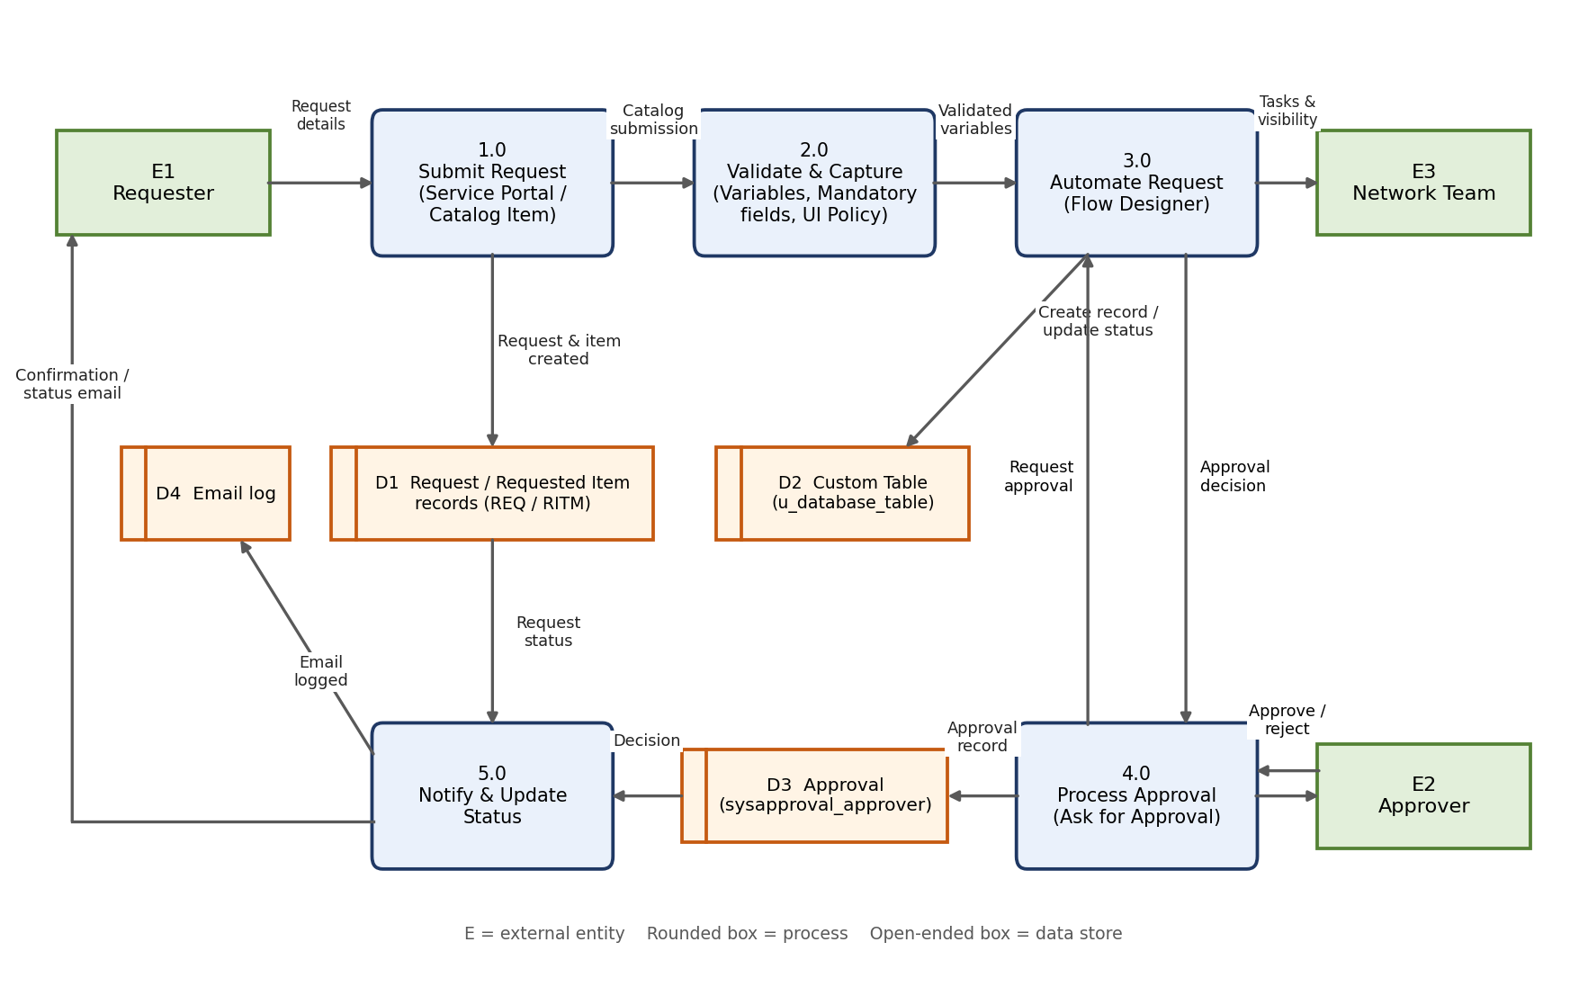
Figure 3.1: Level-1 Data Flow Diagram of the Automated Network Request Management solution
Table 3.2: Data flow diagram elements
Element | Name | Description
E1 | Requester | Submits the request and receives confirmation / status email.
E2 | Approver | Receives the approval record and approves or rejects it.
E3 | Network team | Views requests and works catalog tasks through list views.
1.0 | Submit request | Requester opens the Network Request catalog item on the Service Portal and submits it.
2.0 | Validate & capture | Catalog variables, mandatory fields and the Catalog UI Policy validate and capture the input.
3.0 | Automate request | Flow “Network Request”: Get Catalog Variables, Create Record, Send Email, Ask For Approval, Update Record.
4.0 | Process approval | Approval record is raised and the decision returns to the flow.
5.0 | Notify & update status | Confirmation email is generated and logged; request status is updated.
D1–D4 | Data stores | D1 request / requested item records; D2 custom table u_database_table; D3 Approval (sysapproval_approver); D4 email log.

3.4 Technology Stack
Table 3.3: Technologies used (all supported by the project documentation and screenshots)
Layer | Technology / feature | Use in the project
Platform | ServiceNow (instance dev190678, Global application scope) | Host platform for all configuration
Front end | Service Portal (/sp) | Requester access, search and submission
Intake | Service Catalog; Network Request catalog item; catalog variables and a variable set (Requester Information) | Structured request form
Form logic | Catalog UI Policy and UI Policy Actions | Conditional field visibility
Data | Custom table (Database Table, u_database_table); Request / Requested Item and catalog task tables | Storage of network request data
Relationship | System Definition > Relationships (“Approval Request”, ECMAScript query script) | Approval related list on the request
Approvals | Approval records (sysapproval_approver) | Approval tracking
Automation | Flow Designer / Workflow Studio: Get Catalog Variables, Create Record, Send Email, Ask For Approval, Update Record, If / Else flow logic | End-to-end automation
Notification | Email (SMTP) notifications and email log | Requester confirmation
Security | Role-based access control | Restricted view / create / update

4. PROJECT DESIGN

4.1 Problem Solution Fit
The problem is that network requests are received in an unorganized, manual way, without a consistent record or enforced approval. The implemented solution fits this problem because every stated need maps to a configured ServiceNow capability that is evidenced in this report.
Table 4.1: Problem–solution fit
Need | Solution component | Evidence
Single, structured way to raise a network request | Network Request catalog item on the Service Portal | Figs. 4.1, 4.9, 7.1
Consistent record with requester and request information | Custom table u_database_table populated through the catalog | Figs. 4.3, 4.4, 7.2
Fewer errors and cleaner data | Ordered variables, mandatory fields, UI Policy | Figs. 4.8, 4.10, 4.11
Approval and compliance control | Approval Request relationship; Ask For Approval | Figs. 4.5, 4.6, 7.5–7.7
Less manual routing | Flow “Network Request” automation | Figs. 7.4, 7.5
Visibility for approvers and network teams | Related list, Approvals list, catalog tasks, list views | Figs. 7.2, 7.3, 7.6
Timely feedback to the requester | Send Email action and confirmation email | Fig. 7.10

Scope of the fit. The solution addresses intake, approval tracking, automation and notification. Items that would strengthen the fit further, such as SLA-based escalation, multi-level approvals and reporting dashboards, are not part of the current implementation and are listed in Section 10.

4.2 Proposed Solution
The proposed (and implemented) solution is an automated network request management process on ServiceNow:
- The requester opens the Service Portal and searches for “Network Requests”.
- The requester completes the Network Request catalog form; conditional fields appear through the Catalog UI Policy and mandatory fields are enforced.
- On submission a request number is generated and the catalog item triggers the flow “Network Request”.
- Flow Designer gets the catalog variables, creates the network request record, sends an email and raises an approval.
- The approval record is linked to the network request through the Approval Request relationship.
- Once the approval decision is made, the flow updates the record; approvers and network teams track requests through list views.

The following subsections document how each part of the solution was configured.

4.2.1 Application and Catalog Item Creation
The Network Request catalog item is configured in the Service Catalog (Category: Network Standard Changes, Application: Global, Owner: System Administrator, short description “Network Services Request”). It is mapped to the custom network request table and carries seven catalog variables, one variable set and one Catalog UI Policy.
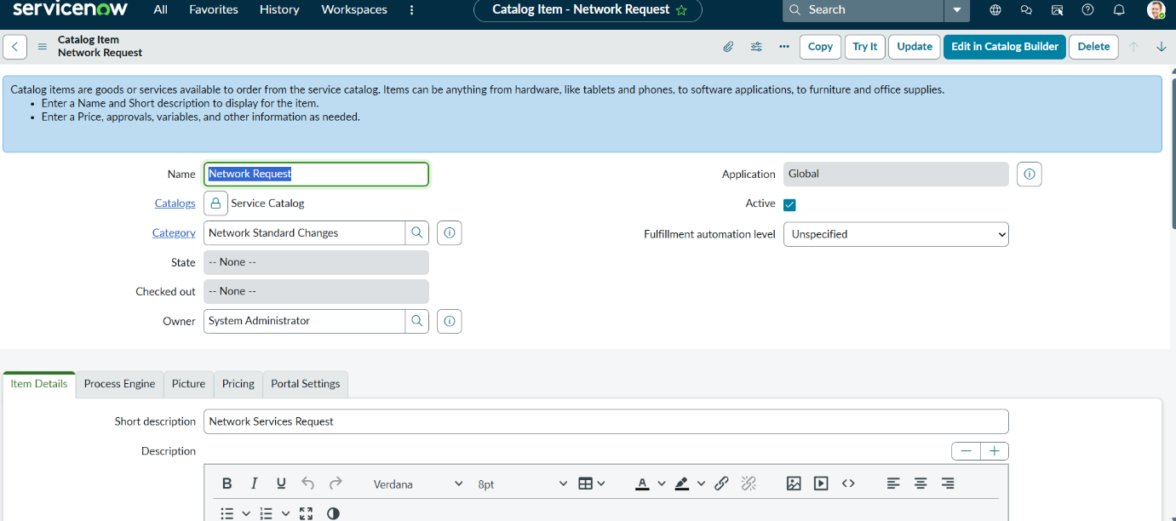
Figure 4.1: Network Request catalog item — Item Details
The catalog item form shows the name, catalog, category, owner and short description configured for the Network Request item.
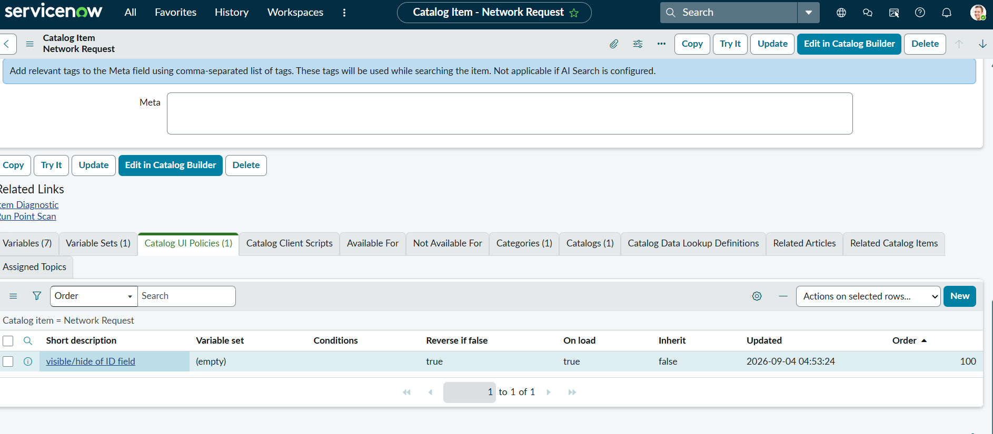
Figure 4.2: Network Request catalog item — related lists
The related lists show Variables (7), Variable Sets (1) and the Catalog UI Policy “visible/hide of ID field”.

4.2.2 Custom Table and Data Architecture
The solution is built on a structured data model that combines standard platform tables with a custom network request table for clarity, scalability, and control. Network requests are captured through catalog-driven records and stored with well-defined fields. Forms display only relevant information using UI logic, while mandatory fields enforce data accuracy and compliance. List views provide operational visibility for approvers and network teams, enabling efficient tracking of requests, tasks, and statuses. This architecture supports secure access, automation, and reporting across the request lifecycle.
The custom table is labelled “Database Table” (name u_database_table, Global application) and has 15 columns, listed in Table 4.2. “Database Number” is generated with the auto-number script shown in the table definition.
Table 4.2: Columns of the custom table u_database_table (from Figs. 4.3 and 4.4)
Column label | Type | Notes
Database Number | String | Auto-generated number (getNextObjNumberPadded script); example DAT00001010
Requested For | String | Person for whom the request is raised
Mobile Number | String | Requester contact number
Type of Connection | String | New / Existing
Total Amount | String | Amount entered on the request
Mode of Payment | String | For example UPI or card
Address | String | Address entered on the request
Assigned To | Reference (User) | Assignee of the record
Approval Status | String | Approval outcome stored on the record (for example Approved)
Sys ID; Created; Created by; Updated; Updated by; Updates | GUID; Date/Time; String; Date/Time; String; Integer | Standard system columns

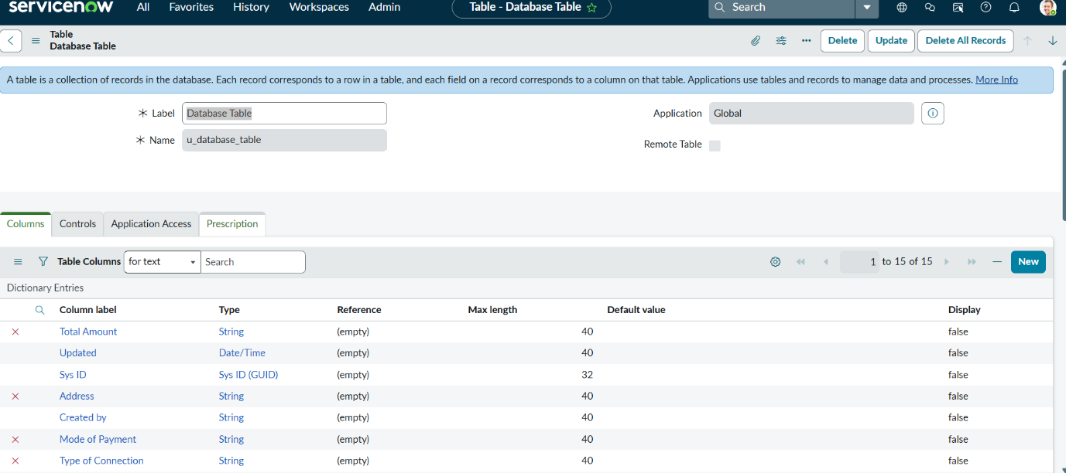
Figure 4.3: Custom table definition (Database Table, u_database_table)
The table definition and the first set of dictionary entries.
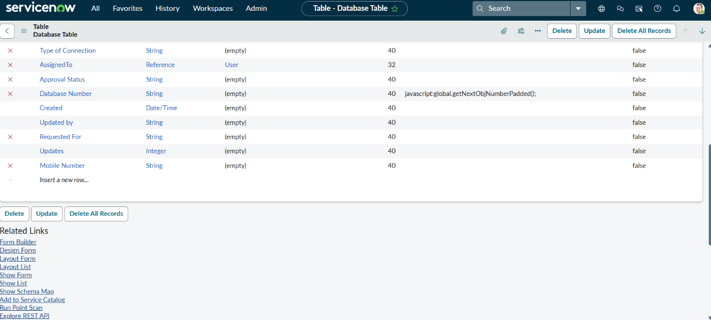
Figure 4.4: Custom table columns (continued)
Remaining dictionary entries, including Assigned To, Approval Status, Database Number, Requested For and Mobile Number.

4.2.3 Approval Request Relationship
A related list was created so that approval records appear directly on the network request form, giving requesters and approvers a single place to track approval status.
Table 4.3: Relationship configuration — Activity 1: Creation of Related List
Step | Setting
1 | Navigate to System Definition > Relationships and click New.
2 | Name: Approval Request.
3 | Applies to table: the custom network request table (Database Table [u_database_table]).
4 | Queries from table: the approval table (Approval [sysapproval_approver], referred to as sysapprovals in the original documentation).
5 | Active: True. Save the relationship.
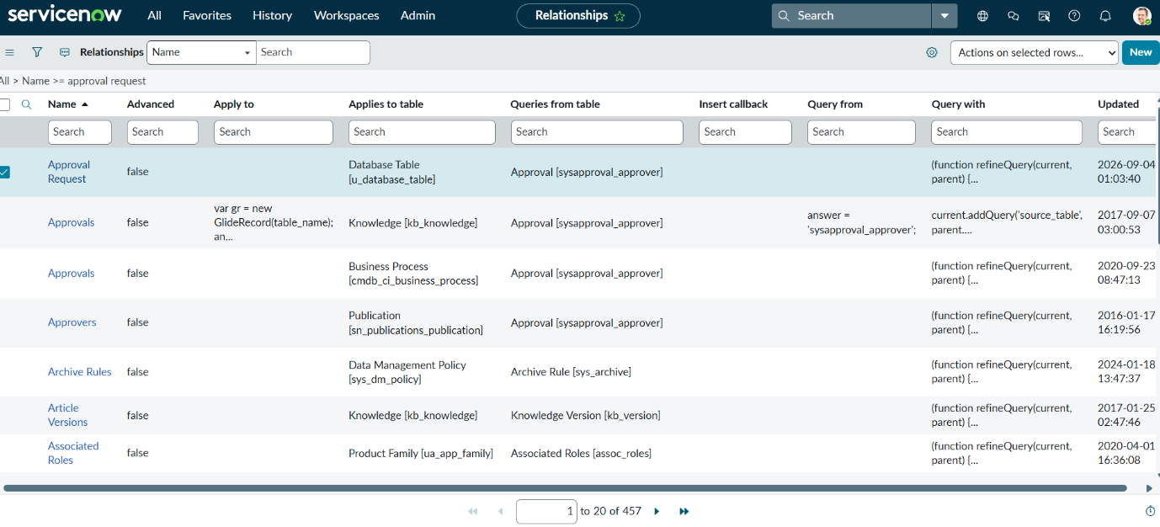
Figure 4.5: Relationships list — “Approval Request” relationship
The new relationship is listed with Applies to table = Database Table and Queries from table = Approval [sysapproval_approver].
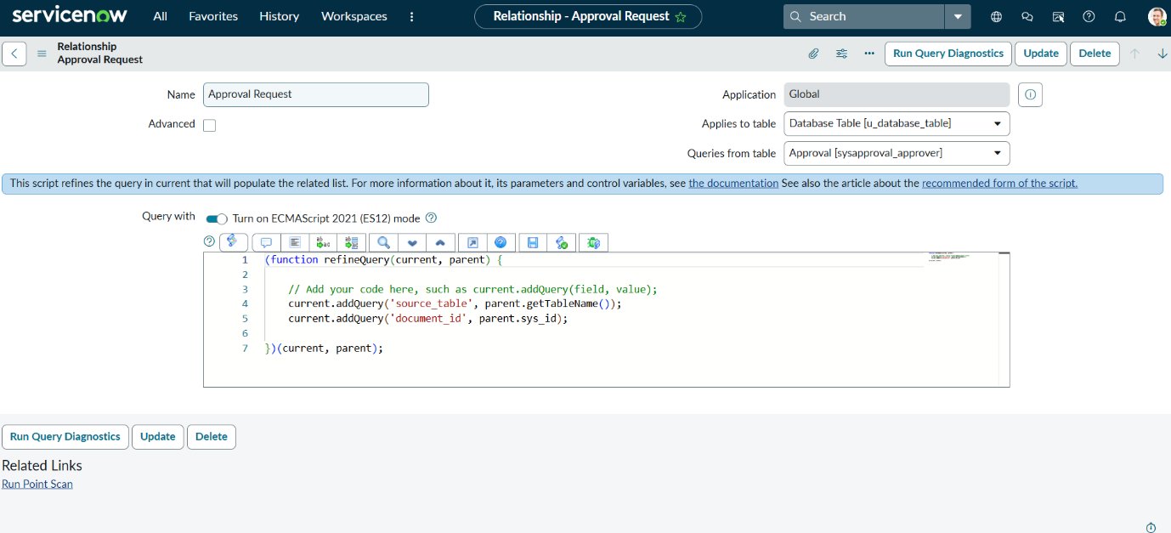
Figure 4.6: Relationship configuration and query script
The query script refines the related list using the source table name and the parent record’s sys_id (see Appendix A).

4.2.4 Form Design and Field Configuration
The Network Request form collects the information required to process a request. System-generated information (such as the request number) is kept separate from user-entered or selected information. A Requester Information variable set (Opened on behalf of, User Name, Email ID, Phone Number) precedes the request-specific variables.
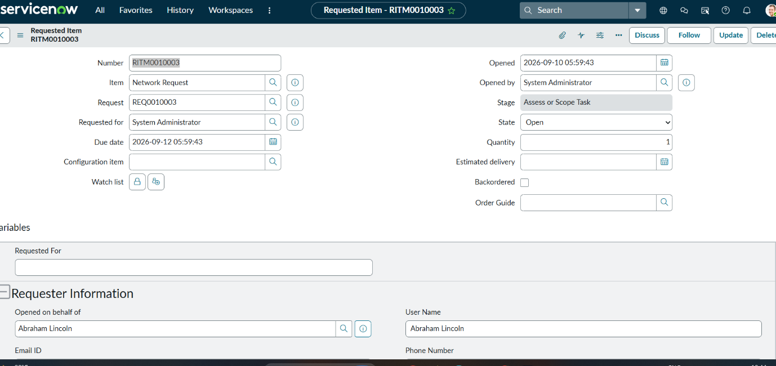
Figure 4.7: Requested Item form (RITM0010003) for the Network Request item
The requested item shows the item, request, requester and requester-information variables generated from the catalog form.

4.2.5 Catalog Variables Configuration
Variables are configured on the Network Request catalog item to build the form fields presented to the requester. Variable types used are Single Line Text and Multiple Choice (the catalog framework also supports Multi Line Text, Reference and Choice, selected per requirement).
- Order values (100, 200, 300, …) control the display sequence of fields.
- Question: the label shown to the requester.
- Name: the internal variable name used for scripting.
- Tooltip: guidance shown when the cursor hovers over the field.
- Example text: sample input to guide the requester.
- Mandatory / Read-only: configured as required per field.
- Auto-populate: dependent variables use dot-walking to pull related values automatically.

Table 4.4: Catalog variables of the Network Request item (from Fig. 4.8)
Order | Question | Type
100 | Requested For | Single Line Text
200 | Mobile Number | Single Line Text
300 | Type of Connection | Multiple Choice
400 | Enter your existing ID | Single Line Text
500 | Total Amount | Single Line Text
600 | Mode of Payment | Multiple Choice
700 | Address | Single Line Text
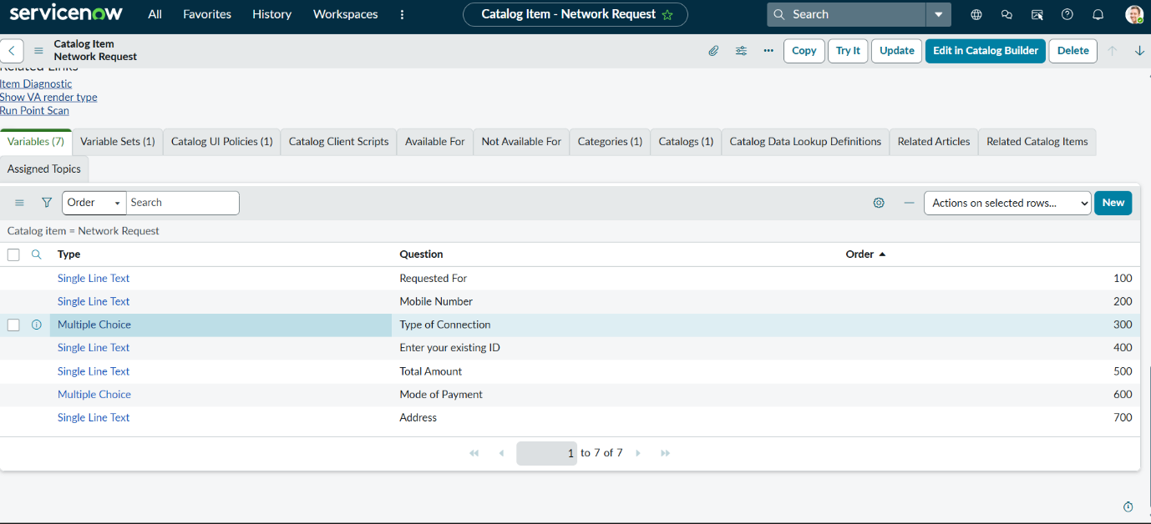
Figure 4.8: Catalog variables of the Network Request item
Seven variables in display order 100–700.

4.2.6 Navigation Flow
- Log in to the ServiceNow instance.
- Copy the instance domain, for example https://dev190678.service-now.com.
- Append the /sp prefix to reach the Service Portal, for example https://dev190678.service-now.com/sp.
- Search for “Network Requests”.
- Fill in the required details and click Submit.
- A new request is generated with a request number, and the requester receives a confirmation email.
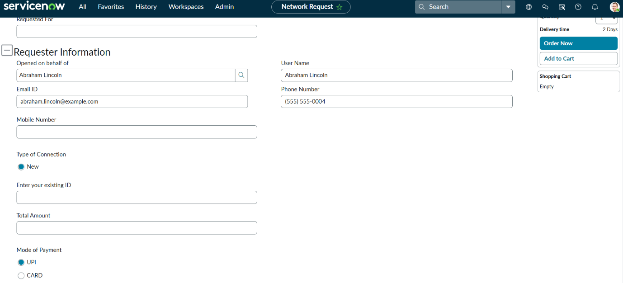
Figure 4.9: Network Request form on the Service Portal
The portal form shows Requester Information, Type of Connection, Existing ID, Total Amount and Mode of Payment, with Order Now / Add to Cart options.

4.2.7 UI Policy and Conditional Validation
Catalog UI Policies display additional fields when certain choices are made, using conditional logic and field dependencies configured within ServiceNow.
Scenario: If the user selects “Type of Connection” = Existing, the Existing ID field is displayed.

Procedure:
- Navigate to the Network Request catalog item.
- Open the Catalog UI Policy related list and click New.
- Set Applies to = Catalog item, and Catalog item = Network Request.
- Provide a short description and the triggering condition (for example, Type of Connection is Existing).
- Save, then configure the UI Policy Action for the target variable and set it Visible = True.
- Update the UI Policy and test it on the catalog form.
The configured policy “visible/hide of ID field” applies on the catalog item view and catalog tasks, runs on load, and reverses its effect if the condition is false; its action makes enter_your_existing_id visible.
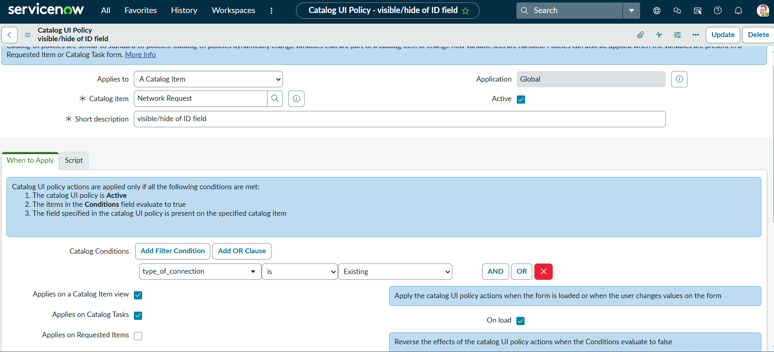
Figure 4.10: Catalog UI Policy — conditions
Condition: type_of_connection is Existing; Applies to a Catalog Item = Network Request.
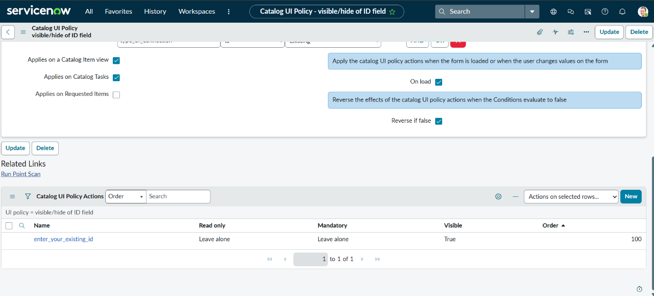
Figure 4.11: Catalog UI Policy — options and actions
Applies on Catalog Item view and Catalog Tasks, On load and Reverse if false enabled; action enter_your_existing_id set to Visible = True.

4.2.8 Automation — Flow Designer
Flow Designer logic implements Get Catalog Variables, Create Record, Ask for Approval, Send Email and Update Record, triggered on catalog item submission and supporting dynamic automation.
Activity 1: Creation of Flow
- Navigate to the Flow Designer home page.
- Click New to create a new flow.
- Provide the flow name: Network Request.
- Provide a description of the flow.
- Click Build flow, then add the Get Catalog Variables, Create Record, Ask for Approval, Send Email and Update Record actions.

Table 4.5: Flow actions as shown in the flow execution (Fig. 7.5)
# | Action / logic | Purpose
1 | Get Catalog Variables | Reads the submitted catalog variables from the Network Request item
2 | Create Record | Creates the network request record
3 | Send Email | Sends the confirmation email to the requester
4 | Ask For Approval | Raises the approval record and waits for the decision
5–6 | If Request is Approved → Update Record | Updates the record when approved
7–8 | Else → Update Record | Alternative update path when not approved (shown “Not Run” in the captured execution)

The original documentation lists the actions in the order Ask for Approval, then Send Email; the execution record in Fig. 7.5 shows Send Email executing before Ask For Approval. The order shown in the execution record is used above.

4.2.9 Access Control
Role-based access control restricts who can view, create, and update network request records and approvals, ensuring that only authorized requesters, approvers, and network team members can act on a given request. Approval records created by the flow are visible to the approver through the Approvals list and the approval record.

4.3 Solution Architecture
The solution is organized in four layers, with role-based access control and the Approval Request relationship applying across them (Figure 4.13): (1) the user layer — requester, approver and network team; (2) the presentation layer — Service Portal, the Network Request catalog item and the Catalog UI Policy; (3) the automation layer — the Flow Designer flow; and (4) the data layer — the custom table, request / requested item and catalog task records, approval records and the email log.
The end-to-end functional flow is shown in Figure 4.12 and described step by step in Table 4.6: Requester → Service Portal → Network Request catalog item → Custom Table → Approval (sysapprovals) → Flow Designer → Notification.
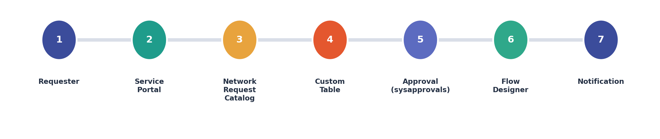
Figure 4.12: End-to-end functional flow — Requester to notification
Table 4.6: Functional flow — component responsibilities
Step | Component | Function
1 | Service Catalog | Requester submits the Network Request catalog item.
2 | Catalog Variables | Capture the request information.
3 | UI Policy | Display conditional fields based on connection type.
4 | Custom Table | Store the network request record.
5 | Approval Request Relationship | Link the request to its approval (sysapprovals) record.
6 | Flow Designer | Create record, request approval, send email, update record status.
7 | List Views | Give approvers and network teams visibility into requests and status.
8 | Notification | Requester receives email confirmation and status updates.
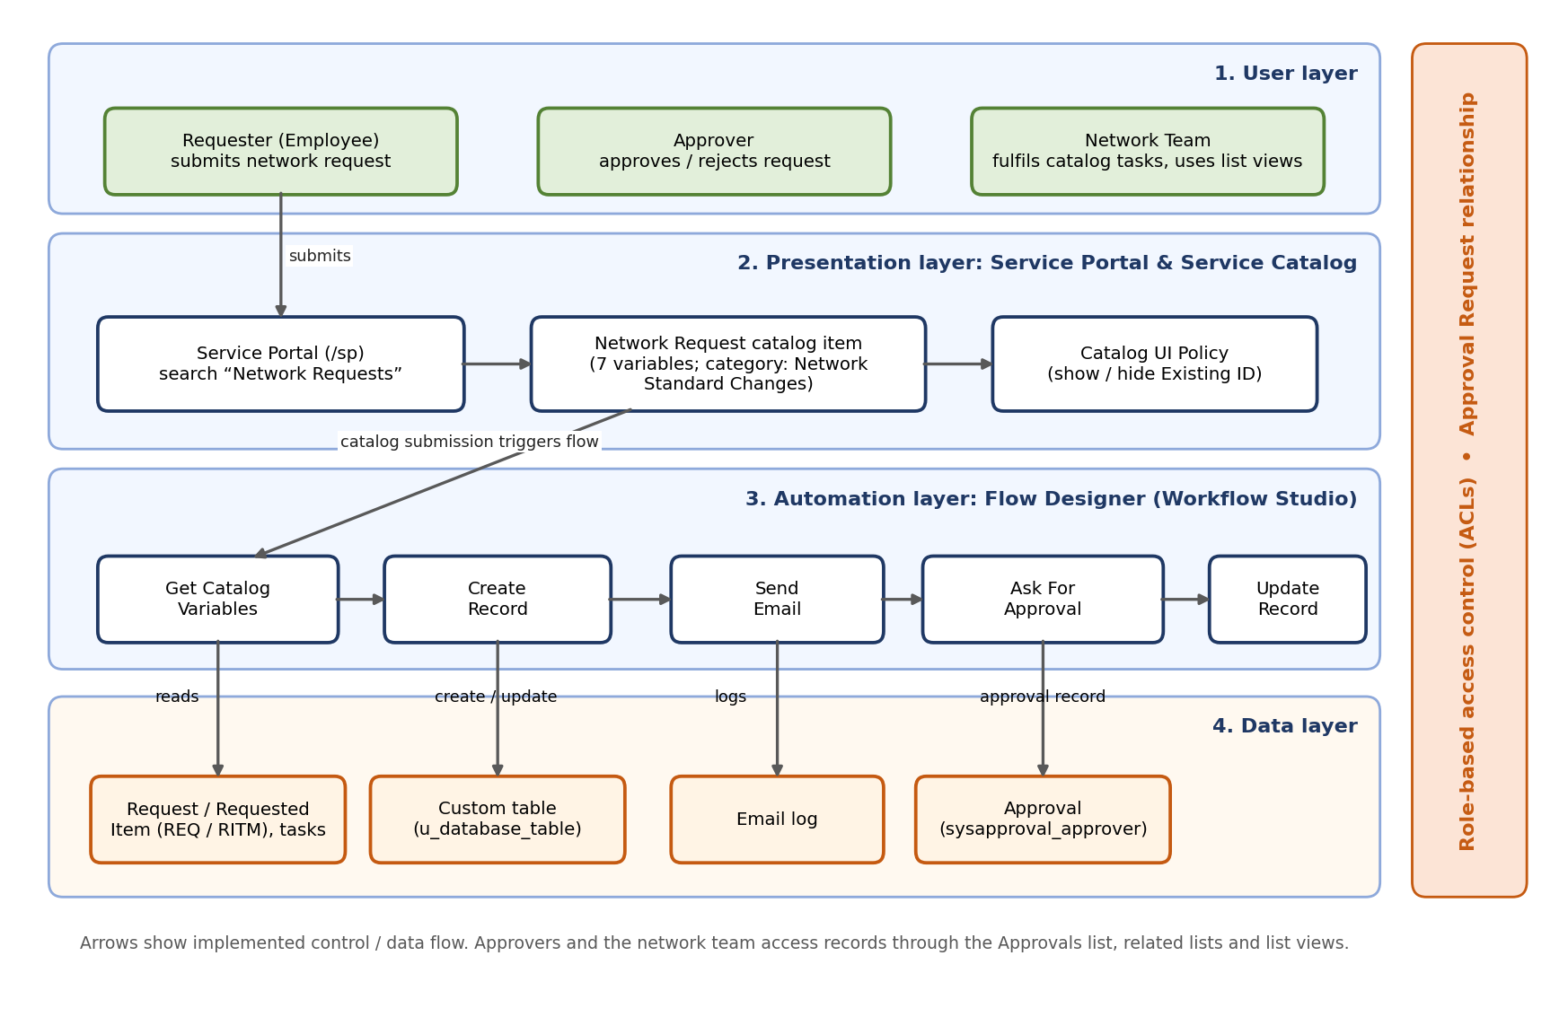
Figure 4.13: Solution architecture of the Automated Network Request Management application

5. PROJECT PLANNING & SCHEDULING

5.1 Project Planning

Table 5.1: Phase-wise project plan (proposed)
Phase | Key activities | Deliverable | Status
1. Ideation | Problem statement, empathy map, brainstorming of approaches | Sections 2.1–2.3 | Completed
2. Requirement analysis | Journey map, functional and non-functional requirements, data flow, technology stack | Sections 3.1–3.4 | Completed
3. Design | Catalog item, data model, relationship, form and variable design, UI Policy design, solution architecture | Section 4 | Completed
4. Implementation | Build catalog item, custom table, relationship, variables, UI Policy, Flow Designer flow, access control | Working application | Completed
5. Testing | Functional test cases TC-01 to TC-07; performance tests | Section 6 | Functional testing completed; formal performance testing not performed
6. Documentation | Final project report, screenshots, demo recording | This report; demo link | Completed

Table 5.2: Milestones
Milestone | Status
Requirements and design complete | Completed
Application build complete (catalog, table, flow) | Completed
Functional testing complete | Completed
Final report submitted | Completed

6. FUNCTIONAL AND PERFORMANCE TESTING
Functional testing
Functional QA testing covered catalog submission, conditional UI Policy behaviour, approval routing, automation execution, and record visibility for approvers and network teams. Data integrity is enforced by mandatory fields, reference fields, and dependent / auto-populated variables, ensuring that records entering the network request table are complete and consistent.
Table 6.1 lists the seven functional test cases, their expected outcomes, the figures in this report that support each result, and the recorded result. All seven test cases passed.
Table 6.1: Functional test cases
ID | Test | Expected outcome | Evidence | Result
TC-01 | Submit network request | Request record is created in the custom network request table. | Figs. 7.1, 7.2 | Pass
TC-02 | Mandatory field validation | Form blocks submission until required fields are completed. | Fig. 4.1 (catalog item) | Pass
TC-03 | Connection type = Existing | Existing ID field becomes visible per UI Policy. | Policy configuration: Figs. 4.10, 4.11 | Pass
TC-04 | Approval relationship | Approval Request related list shows the linked approval record. | Fig. 7.2 | Pass
TC-05 | Flow Designer execution | Get Catalog Variables, Create Record, Ask for Approval, Send Email and Update Record execute successfully on submission. | Figs. 7.4, 7.5 | Pass
TC-06 | Notification | Requester receives an email confirming submission. | Figs. 7.9, 7.10 | Pass
TC-07 | List view visibility | Approvers and network teams see the request and its current status. | Figs. 7.3, 7.6, 7.8 | Pass

6.1 Performance Testing
No formal performance test was performed for this project. The only measurements available are the action durations captured in the Flow Designer execution record of a single test run (Figure 7.5). They are reported below as observations, not as a benchmark.
Table 6.2: Observed flow action durations (single test run, Fig. 7.5)
Flow step | Observed duration
Get Catalog Variables | 20 ms
Create Record | 6 ms
Send Email | 28 ms
Ask For Approval (up to creation of approval; flow then waits for the approver) | 144 ms
Update Record (If Request is Approved) | 8 ms

Note:
Functional testing was completed for the Automated Network Request Management system in ServiceNow. The implemented functionality, including request submission, dynamic form behaviour, record creation, approval processing, email notifications, and request status tracking, was tested. However, formal performance measurements, such as response times, flow execution times, and concurrent-user load testing, were not performed. Therefore, no numerical performance targets or results are reported. Formal performance benchmarking may be considered as a future enhancement.

Table 6.3: Planned performance tests
ID | Test | Metric
PT-01 | Catalog form load time on Service Portal | Seconds to load
PT-02 | Request submission response | Seconds from Submit to Order Status page
PT-03 | Flow execution time (end to end, excluding approval wait) | Milliseconds / seconds
PT-04 | Concurrent submissions (for example 10, 25, 50 users) | Success rate, flow queue delay
PT-05 | Approval-to-record-update latency | Seconds
PT-06 | List view load with large record counts | Seconds
PT-07 | Email notification delivery time | Seconds from submission to email generated / sent

7. RESULTS
This section presents the output screenshots from the working application. Each figure is an unmodified capture from the original project documentation and is explained below it; only behaviour visible in the screenshots is claimed.

7.1 Output Screenshots
Table 7.1: Summary of verified results
Result | Evidence
Network request submitted from the Service Portal; request number generated | Fig. 7.1
Network request record created with requester and request data | Fig. 7.2
Approval linked to the record through the related list | Fig. 7.2
Catalog tasks created for the requested item | Fig. 7.3
Flow executed (waiting for approval, then completed) | Figs. 7.4, 7.5
Approval records listed and approved | Figs. 7.6, 7.7
Request approved | Fig. 7.8
Confirmation email content generated | Figs. 7.9, 7.10

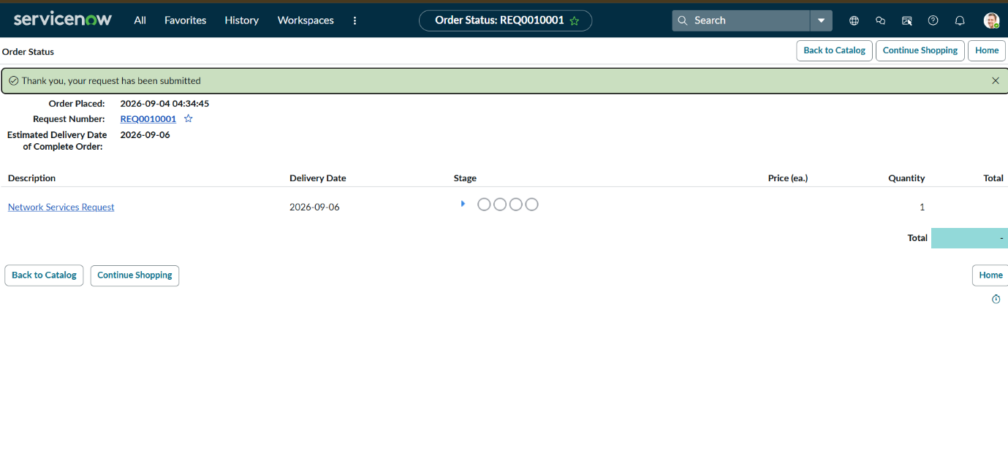
Figure 7.1: Order Status page after submission (REQ0010001)
The confirmation banner “Thank you, your request has been submitted” appears with the request number REQ0010001 and the Network Services Request item.
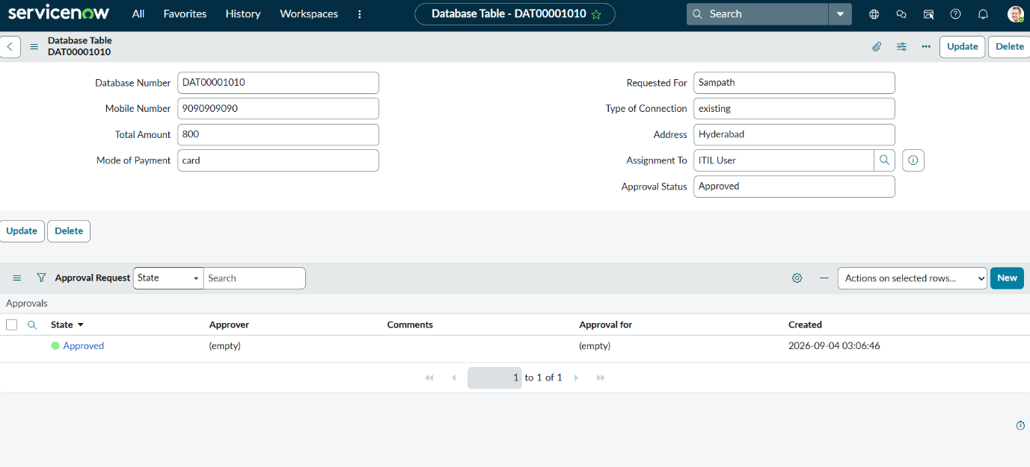
Figure 7.2: Network request record DAT00001010 with Approval Request related list
The custom-table record holds Requested For, Mobile Number, Type of Connection (existing), Total Amount, Address, Mode of Payment and Approval Status (Approved); the related list shows one Approved approval record.
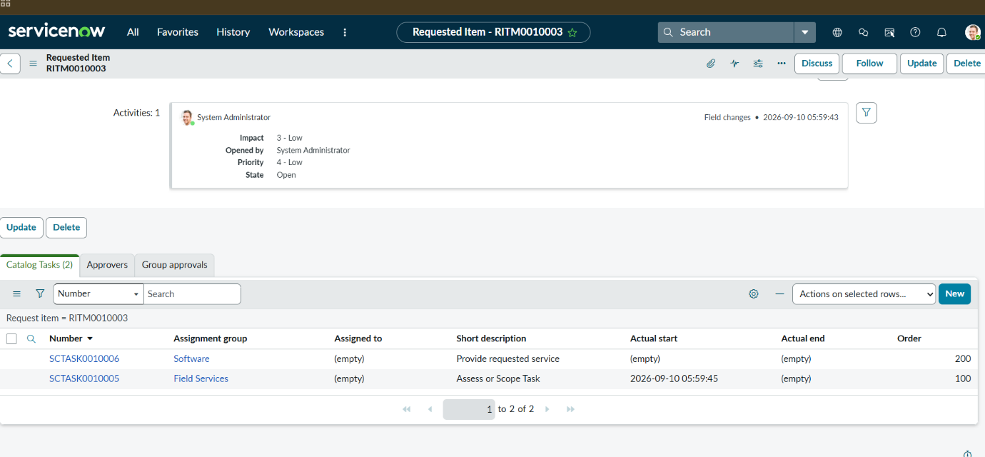
Figure 7.3: Requested item RITM0010003 — catalog tasks
Two catalog tasks were created: SCTASK0010005 (Field Services, Assess or Scope Task) and SCTASK0010006 (Software, Provide requested service).
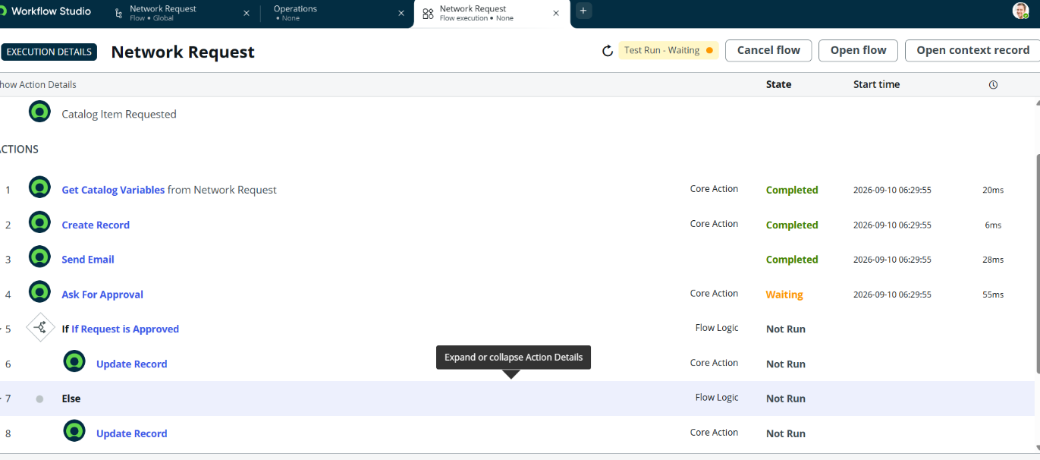
Figure 7.4: Flow execution “Network Request” — waiting for approval
Get Catalog Variables, Create Record and Send Email show Completed; Ask For Approval shows Waiting; the If / Else update steps are Not Run.
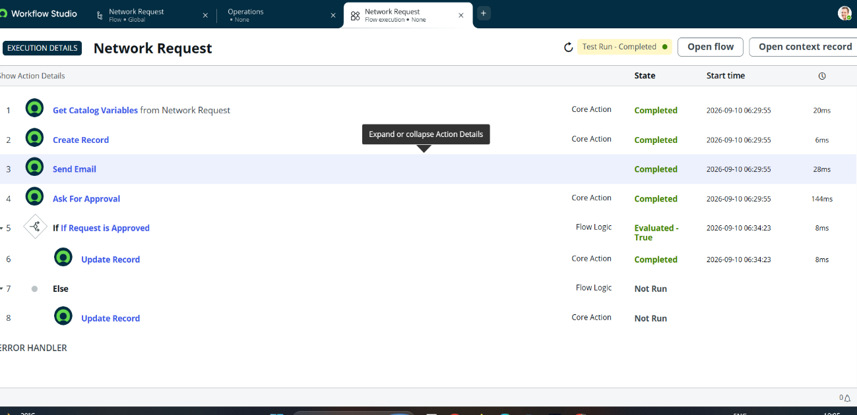
Figure 7.5: Flow execution “Network Request” — completed
After approval the flow shows Test Run – Completed, the condition “If Request is Approved” evaluates True and Update Record completes.
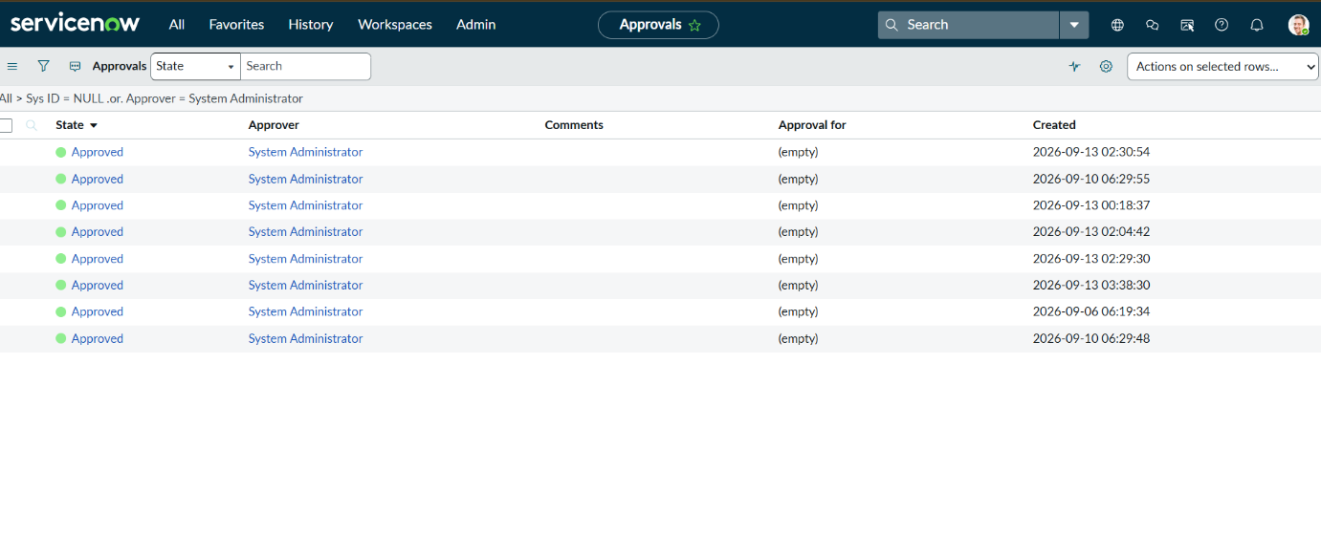
Figure 7.6: Approvals list
Approval records for the System Administrator approver are listed in the Approved state.
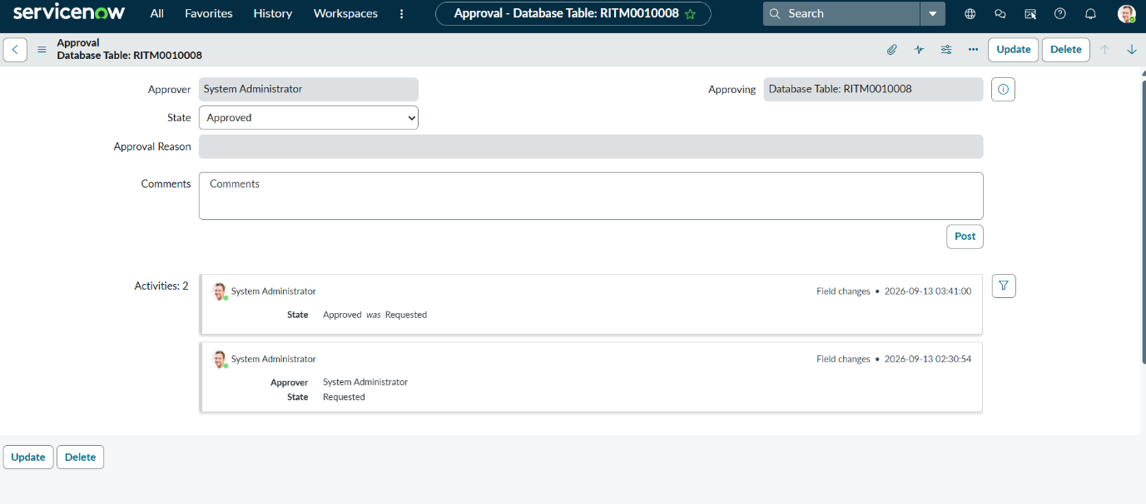
Figure 7.7: Approval record for RITM0010008
The approval record shows approver, approving record, state Approved and the activity history of the state change.
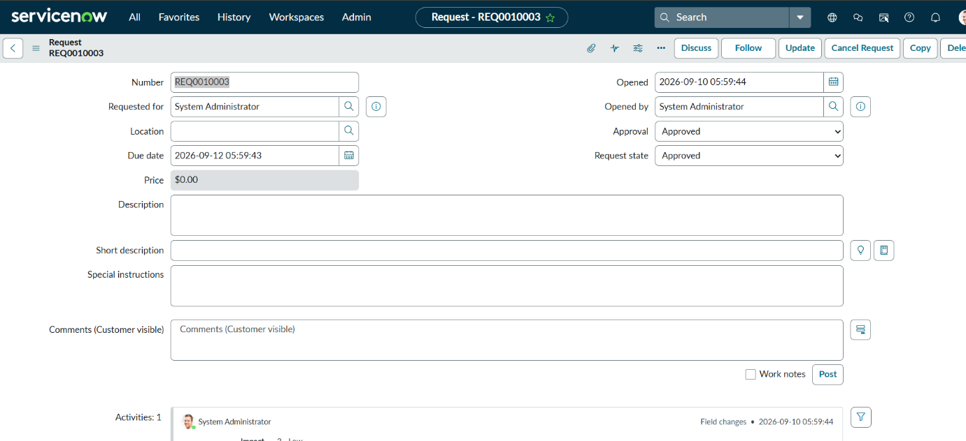
Figure 7.8: Request REQ0010003 — approved
The request shows Approval = Approved and Request state = Approved.
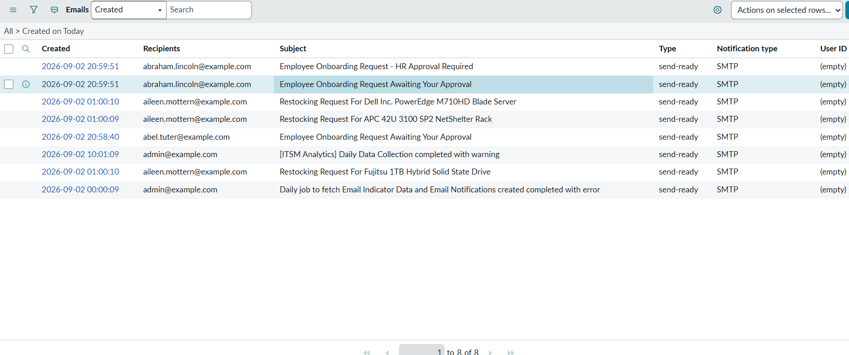
Figure 7.9: Email log (list view)
The email log lists generated emails with recipients, subject and type (send-ready, SMTP). The list also contains other sample emails present on the instance.
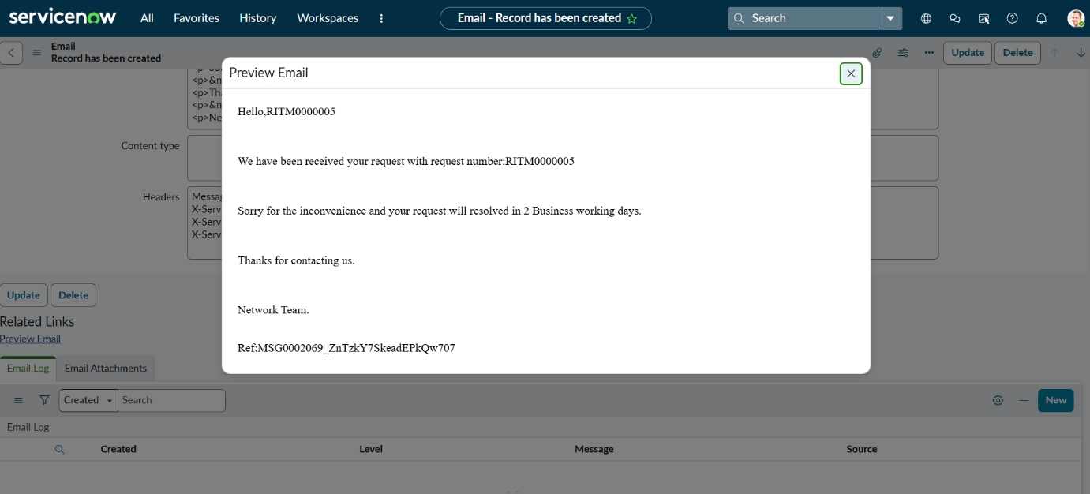
Figure 7.10: Confirmation email preview
The preview shows the confirmation message with the request number (RITM0000005), the two-business-day resolution statement and the Network Team signature.

8. ADVANTAGES & DISADVANTAGES
Advantages
- Structured intake: one catalog form replaces unorganized manual requests.
- Consistent data: ordered variables and a dedicated custom table keep requester and request information uniform.
- Conditional logic: UI Policies show fields only when relevant.
- Approval traceability: the Approval Request relationship shows approval status on the request itself.
- Automation: Flow Designer reduces manual routing and updates records after approval.
- Visibility: approvers and network teams can use list views, approval lists and catalog tasks.
- Low-code and maintainable: the solution uses standard ServiceNow configuration, so it can be extended without custom application code.
- Immediate feedback: the requester receives a request number and a confirmation email.
Disadvantages and limitations
- Performance has not been measured beyond one flow run; load behaviour is unknown.
- Approvals shown are single-level; no multi-level hierarchy, SLA-based escalation or automated reassignment.
- The custom table and several fields use generic labels and text types (for example, Total Amount and Mode of Payment are strings), which limits validation and reporting.
- No reporting dashboards or CMDB integration for network configuration items.
- Role and ACL details are not fully documented, so the security model cannot yet be independently reviewed.
- The solution was demonstrated on a development instance with sample users; behaviour in production has not been assessed.

9. CONCLUSION
The Automated Network Request Management project demonstrates an end-to-end ServiceNow solution covering catalog-based intake, structured data storage, conditional form logic, approval tracking, and Flow Designer automation.
Key achievements
- Structured data architecture combining standard and custom network request tables.
- Network Request catalog item with ordered, well-configured variables.
- Conditional UI Policy for the connection type scenario.
- Approval Request relationship linking requests to approval (sysapprovals) records.
- Flow Designer automation covering the request lifecycle: variables, record creation, email, approval and record update.
- Role-based access control and validated data integrity.
All seven functional test cases (TC-01 to TC-07) passed. Formal performance testing was not performed, as set out in Section 6.

10. FUTURE SCOPE
The following enhancements may be considered in future versions of the Automated Network Request Management system in ServiceNow:
- SLA-based escalation and automated reassignment: Introduce service-level agreements (SLAs) to monitor overdue requests and automatically reassign them when necessary.
- Deeper CMDB integration: Integrate network requests with Configuration Management Database (CMDB) records to improve tracking of network configuration items.
- Reporting dashboards: Develop dashboards to monitor request volume, approval turnaround time, and fulfilment time.
- Multi-level approval hierarchies: Extend the approval workflow to support multiple approval levels based on request type, cost, or organizational policy.
- Additional request types: Support more network service request categories to accommodate different organizational requirements.
- Knowledge-article recommendations: Recommend relevant knowledge articles during request submission to help users resolve common issues and provide the required information.

11. APPENDIX
A. Source Code (if any)
No separate source-code files were supplied. The only script visible in the project screenshots is the query script of the “Approval Request” relationship (Figure 4.6):
(function refineQuery(current, parent) {
// Add your code here, such as current.addQuery(field, value);
current.addQuery('source_table', parent.getTableName());
current.addQuery('document_id', parent.sys_id);
})(current, parent);

B. Dataset Link
Not applicable. The project does not use an external dataset. Test data was generated by submitting network requests through the ServiceNow Service Portal. An example of a generated request record is DAT00001010. No separate dataset file is required for this project.
C. GitHub & Project Demo Link
Item | Link
GitHub repository | https://github.com/harikajetti20-dev/Automated-Network-Request-Management.git
Project demo / walkthrough (recorded) | https://drive.google.com/file/d/1WjS0AEqxdho9KFJY0qqG3X2gI9L0dVYY/view?usp=sharing

Demo link: Watch the Project Demo

